**Find largest and smallest from set:**

CODE:

my_set = {10, 20, 30, 40, 50}  
  
my_list = list(my_set)  
  
print(my_list)  
  
if my_list:  
 largest = smallest = my_list[0]  
  
 for num in my_list:  
 if num > largest:  
 largest = num  
 if num < smallest:  
 smallest = num  
  
 print("Largest element:", largest)  
 print("Smallest element:", smallest)  
else:  
 print("Set is empty.")

OUTPUT:

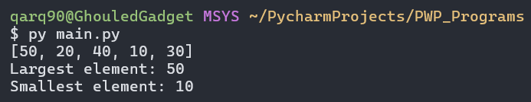

**Find Max and Min in a set:**

CODE:

my_set = {10, 20, 30, 40, 50}  
  
my_list = list(my_set)  
  
print(my_list)  
  
if my_list:  
 largest = smallest = my_list[0]  
  
 for num in my_list:  
 if num > largest:  
 largest = num  
 if num < smallest:  
 smallest = num  
  
 print("Max element:", largest)  
 print("Min element:", smallest)  
else:  
 print("Set is empty.")

OUTPUT:

